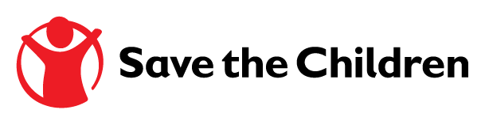

**Tender Notice**

Ref. Number: SCI/TR/Tender/2016/001

Provision of Various Kits under Household Supplies Category

Save the Children is the world’s leading independent organisation for children. We work together, with our partners, to inspire breakthroughs in the way the world treats children and to achieve immediate and lasting change in their lives. As part of the effort, we currently seeking for potential vendors to supply various household items and kits under the umbrella of Framework Agreement. We also intend to include all pre-qualified bidders from this tendering process in our list of pre-qualified supplier database.

If you believe your company is in position to meet our requirement and would like to be considered as potential supplier, please contact our office at the following address:

Tender Committee of Save the Children

Gaffar Okan Bulvary, Mehmet Beyazit Apartment

Asmakat, Odabasi,

Antakya, Hatay

Collection of tender documents: from 21 November until 21 December 2016. Deadline for tender submission: 26 December 2016 at 5pm Turkish time.

Collection and submission of tender documents should be done from 9am to 5pm every weekday.

All current suppliers are advised to re-apply.

Please contact [procurement.turkey@savethechildren.org](mailto:procurement.turkey@savethechildren.org) for further information and clarification, and indicate tender reference number in email subject.