

**Request for Proposal**

**Sourcing & Contracting Solution Selection**

**Save the Children International (SCI)**

**15th November 2016**

# Introduction

Save the Children exists to help children affected by crises, or those who need better healthcare, education and protection. We work on the ground, and we campaign to secure positive change.

Save the Children believes every child deserves a future. Around the world, we give children a healthy start in life, the opportunity to learn and protection from harm.

We do whatever it takes for children – every day and in times of crisis – transforming their lives and the future we share. We reach over 55 million children directly through our and our partners' work in over 60 countries.

As a key component of our ability to deliver help to children, our Supply Chain function supports delivery of the right products and services, in the right quality and to the right place within the required timeframe and at the right cost.

Save the Children has re-defined our operating model for the future as part of our overall business strategy, and has identified key challenges that need to be addressed in our Supply Chain:

* A significant amount of our $550 million + third party cost base is purchased and managed in local markets
* Local Market procurement process(es) is reactive to individual programme delivery needs, with a lack of suitable forecasts and demand planning for goods and services to support these delivery programmes
* We have a just under 400 warehouses, over 3,000 vehicles worldwide and other assets which require improved oversight and management mechanisms
* Our processes and controls need improved risk identification and management, particularly in procurement processes and streamlining and automation versus the manual, paper based processes currently adopted
* The systems that we use to manage our Supply Chain are basic, with a significant Excel spreadsheet use to underpin the way that we operate. Agresso is used for basic Finance functionality with enhancements planned for extending the finance functionality
* The monies we receive from donors are tracked through an awards system known as AMS, which procurement need to plug to ensure spending on source of funds (SOFs) that are valid.

Save the Children International are therefore looking for a third party to:

* Provide, implement and support a license based agreement for a cloud source to contract solution to support our move to a category management based procurement organisation
* Provide insight on available solution and proposed commercials on scope areas included.

The structure of this Request for Proposal is as follows:

* Part 1: Tender Information
* Part 2: Conditions of Tendering
* Part 3: Terms and Conditions of Purchase (which will be signed by the successful Bidder)
* Part 4: Save the Children’s Child Safeguarding Policy
* Part 5: Save the Children’s Anti-Bribery and Corruption Policy
* Part 6: The IAPG Code of Conduct

Thank you for your interest in supporting SCI with this important initiative.

Regards

Jim Ridgwick

Global Head of Procurement, SCI

# Part 1 – TENDER INFORMATION

# Requirement

SCI would like to appoint a third party organisation to provide a Source to Contract solution which will enable a more strategic and collaborative approach to tendering and contracting with suppliers. Currently this ad-hoc activity has no real process or governance. We also foresee the solution being a key enabler in improved SCI oversight of risk/fraud avoidance as well as value creation and cost reductions by maximising competition and supplier contribution.

The third party supplier chosen will be based on key factors to determine the best partner foe SCI:

* Ability to provide, deploy and maintain a solution that matches all (or as many as possible) of the requirements in outlined in Attachment 1.
* The solution’s match to SCI’s IT Design Principles outlined in Appendix B
* Credentials – demonstrating other clients that the third party have delivered similar work to; and critically how the solution has integrated with Agresso (Finance and P2P)
* Team – demonstrating the right level of experience and fit with SCI
* Commercial proposition – representing value delivery for the sector that SCI operates in

The exact waiting is outlined below.

# Supplier Response

Suppliers must adhere to the format of questions outlined under supplier submission.

All attachments must be in a format capable of being successfully opened for reading by Microsoft PowerPoint, Word and Excel 2013 without loss of formatting. You should keep the size of any electronically returned submission to a minimum, using file compression if necessary.

Please keep responses concise and, where practical, include electronic links to where additional relevant information can be found.

Please do not PDF your response and questions should be answered in English.

# Outline Timetable

Set out below is the proposed timetable. This is intended as a guide and whilst SCI does not intend to depart from the timetable it reserves the right to do so at any stage.

| **Target Date** | **Activity** |
| --- | --- |
| 15th November | RfP published |
| 17th November | Confirmation of interest to participate |
| 21st November, 1-2pm | Supplier Briefing |
| 22nd November | Clarification questions closing date |
| 25th November | Return of submissions |
| 28-30th November | Supplier presentations |
| 16th of December | Award |

# 

# Supplier Briefing

Date: Monday 21st November 2016

Time: 13:00 -14:00 (GMT)

Conference Call Details

Telephone:  +44 (0) 20 7213 6060, ID 7731173

# Supplier Contact Point

Potential third party suppliers are asked to include detailed contact information for their organization’s point of contact. SCI will not be responsible for contacting potential third party suppliers through any route other than the nominated contact.

# Considerations

* This RFP for the sourcing tool is not a contract or an offer.
* There is no obligation for SCI to contract for any of the products or services described in the RFP responses. SCI reserves the right to re-bid all or parts of the services detailed in this RFP. Third party suppliers will not be reimbursed for any costs they incur in preparing their RFP responses.
* SCI have engaged an external third party (PWC) to support with the Supply Chain Management Systems project.
* By submission of the response, the supplier warrants that: the prices in the response have been arrived at independently, without consultation, communication, agreement or understanding for the purpose of restricting competition, as to any matter relating to such prices, with any other supplier or with any competitor. Unless otherwise required by law, the supplier has not knowingly disclosed the prices that have been quoted in their response, directly or indirectly, to any other supplier or competitor, nor will they be so disclosed.

# Selection Process

Responses to this RFI are due by **13:00 on Friday 25th of November 2016** to [scicentreprocurement@savethechildren.org](mailto:scicentreprocurement@savethechildren.org). If you have any questions in the meantime please contact [Adam.brown@savethechildren.org](mailto:Adam.brown@savethechildren.org) via email.

# Contract Award Criteria

| **Criteria** | **Definition** | **Weightings** |
| --- | --- | --- |
| Paper based assessment | | |
| Business Alignment | Industry experience, quality of credential/reference customers, business fit with SCI as outlined under ‘Submission of Response’.  Ability to cover the extended scope: Procurement Solution and Specialist areas in your product portfolio. (as described in Attachment 2) | 20% |
| Requirements coverage | Detail approach to meeting the requirements in **Attachment 1**. | 25% |
| Commercial Assessment | | |
| Commercial | Pricing arrangement and an assessment of the fee rates charged by suppliers | 30% |
| Presentation | | |
| Usability | Demo the solution’s ability to meet requirements through scenario based assessment | 25% |

# Core Scope for this RfP

# Desired Outcomes

| **System** | **Desired Outcome** |
| --- | --- |
| **Core Scope for RfP** | |
| Sourcing | Plan, publish, and evaluate sourcing activity across the organisation. Support various methods of sourcing including above and below threshold competitions for charities and NGOs, auctions, mini competitions, frameworks.  Integration with P2P and planning tools |
| Contract Management | Management of SCI’s contract portfolio. A repository of all SCI’s contracts; access to standard contract templates, libraries of standard terms and conditions and associated workflows. Collaborative working with suppliers to support the management of contract negotiation and contract variation. Analytics on key contractual data points  Full audit trail required  Integration with P2P to contract positioning with actual call offs. |

# User Profile

| **Scope Areas** | **Users Profile \*** | **Global Reach** |
| --- | --- | --- |
| Source to Contract | Total: 100  Year 1- 20  Year 2- 50  Year 3 - 100 | Centre– London 5-10 users  Regional – 15-30 users  Countries – 30-60 users |

*User profiles are based on estimates and subject to review

# Extended Scope: Procurement Solutions and Specialist or Category Scope areas

In parallel to this immediate need, SCI is looking to implement solutions across its Supply Chain over the next 3 to 5 years. The desired outcomes and user profile for the extended scope areas are outlined in the next section.

|  |  |
| --- | --- |
| **System** | **Desired Outcomes** |
| **Procurement Solutions** (background to complete capability overview (**Attachment 2**) | |
| Spend Analysis | Analysis of spend data including normalisation of data records, aggregation of spend by both industry standard (UNSPSC, CPV) taxonomy and SCI category structures.  Visualisation of data via dashboards and reports allowing users to manage dashboard content. Multiple and diverse visualisation options available  Spend data to be taken from Agresso |
| Purchase to Pay | An application that supports our purchase to pay process providing internal and external users with access to all valid purchasing methods including electronic catalogue, purchasing of services and purchasing of non-catalogue goods. Application to include financial approval of spend against budget and or contract; conversion of purchase to purchase order; transmittal of order to supplier; all recognised transactions between supplier and SCI (order confirmation, goods dispatch, order to invoice etc.)  User experience to be intuitive and mobile enabled.  Integrated to Agresso for payments  Integrated to Contract Management and Supplier Management as appropriate |
| Supplier Management | Providing capability and metrics to enable SCI to manage its supply base. The ability to categorise our suppliers, enrich supplier records with 3rd party information and record supplier performance and perception  Integration to appropriate modules within the total solution |
| **Specialist or Category Scope Area** (background to complete capability overview (**Attachment 2**) | |
| Food Management | Ability to source food products and track them through the supply chain, ensuring they reach beneficiaries |
| Beneficiary Tracking | Ability to evidence that goods or services reached the intended beneficiaries |
| Medical | Ability to request highly detailed specifications, whilst also being able to run Quality Assurance audits and integrate with a Quality Assurance tool |
| Construction | Ability to include technical specifications within a tender, and must help enforce the submission of dedicated service completion notes |
| Humanitarian Response | Ability to manage Emergency Preparedness Plans and give access to prepositioned stock documents for quick response |

# User Profile

| **Scope Areas** | **User Profile** | **Global Reach** |
| --- | --- | --- |
| **Procurement** | | |
| Spend Analysis | 70-100 | Centre, regional |
| Supplier Management | 80 | Centre, regional, country |
| Purchase to Pay | 800 | Centre, regional, country and field based |
| **Specialist or Category Scope Area** | | |
| Beneficiary Tracking | 2000 | Country and Field Based |

*User profiles are based on estimates and subject to review. Please include a summary of your offering and commercials for Food Management, Construction, Medical and Humanitarian Response based on the user profiles in the core and procurement scope areas.

# 

# Systems, Installed Software and Databases

| **Software Component** | **Product Version** |
| --- | --- |
| Agresso | Milestone 5 (5.7.2 update 1) |
| Microsoft | Office 2013 |
| Internet Explorer | Version 11 |

# 

# Submission of Response:

Provide a response to the below questions; which will be assessed against the criteria outlined. The requested format of response is:

1. PowerPoint or Word with details of your responses to the questions below

2. Excel templates completed outlining detailed requirements, commercials and capability overview (Attachment 1 and 2)

Please find below the mandatory areas to cover for participation in the SCI Sourcing systems RfP.

**Basic Details of Your Organisation**

* Name of the organisation(s) in whose name this is submitted
* Contact name for enquiries about this response:
* Contact position (Job Title):
* Telephone number:
* E-mail address:

**Business Activities**

* Company introduction
* Which systems in the scope does your response relate to? Please complete the Capability Overview tab within Attachment 2
* What is your global footprint in relation to SCI’s operations as outlined in Appendix A?
* Please specify how you would host solutions serving these countries to address issues such as bandwidth.

**Market Perspective & References**

* What is your organisations share (%) in the Source-to-Contract market?
* What elements of the market represent the current growth areas and your perceived current strengths?
* Detail your experience of delivering similar services within the NGO and Charity Sector as well as in other sectors to a similar level of complexity and scale/footprint

a. Please provide details of **two references**

**Proposed Solution**

* Please provide a proposed solution of how you would deliver against the requirements in Attachment 1 as well as on the extended scope areas (Procurement and Specialist or Category Scope areas).
* A relevant case study which demonstrates a successful example of your product, including integration between multiple systems
* Outline details of your service in relation to data integrity and hosting

As part of your answer please update **Attachment 2** to include:

* Different price models that can be used in the market to undertake this work along with a recommendation
* How you will deliver our design principles outlined in Appendix C

**Support Model**

* Please provide details on options and costs for the following services:
  + Training (around go-live and ongoing)
  + System Administration
  + Configuration / ongoing improvements
  + First line support
  + Second line support
  + Upgrades

**Success Criteria**

* Please least the top 5 critical success factors and your solutions / methods to:
  + An on-time, to budget implementation (5 CSFs)
  + Maximising user adoption / user experience (5 CSFs)

**Commercial Model**

Please detail the optimum commercial arrangement for an engagement of this type. As part of your response please include:

* How do you control cost and demonstrate value for money?
* What is the optimum contracting model?
* How would you support growth in user base over the next 5 years?
* Based on the core and extended scope areas please provide your cost estimate on the attached excel on the Tab “Price Breakdown”?
* The “Alternative Pricing” tab has been left blank to provide you with the option to suggest alternative price models alongside, the required price breakdown.
* If asked to deliver the core and extended scope would you partner with other organisations? If so, who are your strategic partners for solution, implementation and delivery (change management and advisory support) how would this relationship work?

Please include all figures in US Dollars. All systems should support SCI’s main languages English, Spanish and French as part of the operations. Please split out system costs, implementation, and post-go-live support.

**Innovation**

* What innovations has your organisation pioneered in the last three years in the market place?
* What is your organisations roadmap for the next three-five years?

# APPENDIX A – SCI GLOBAL FOOTPRINT

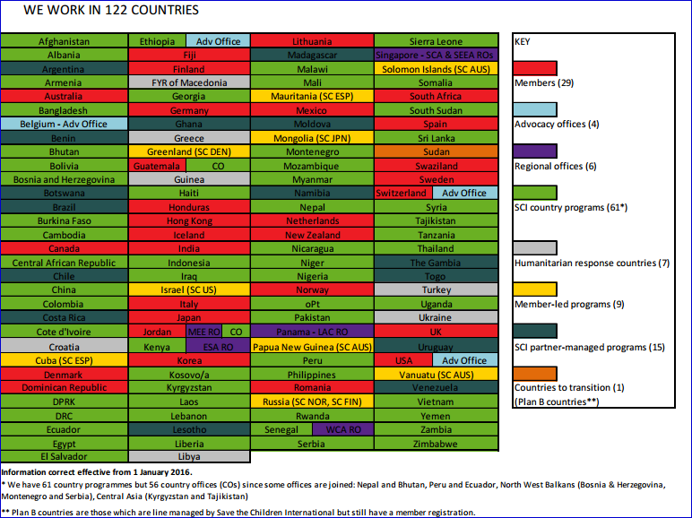

# APPENDIX B – SUPPLY CHAIN SYSTEMS OVERVIEW



**TARGET STATE**

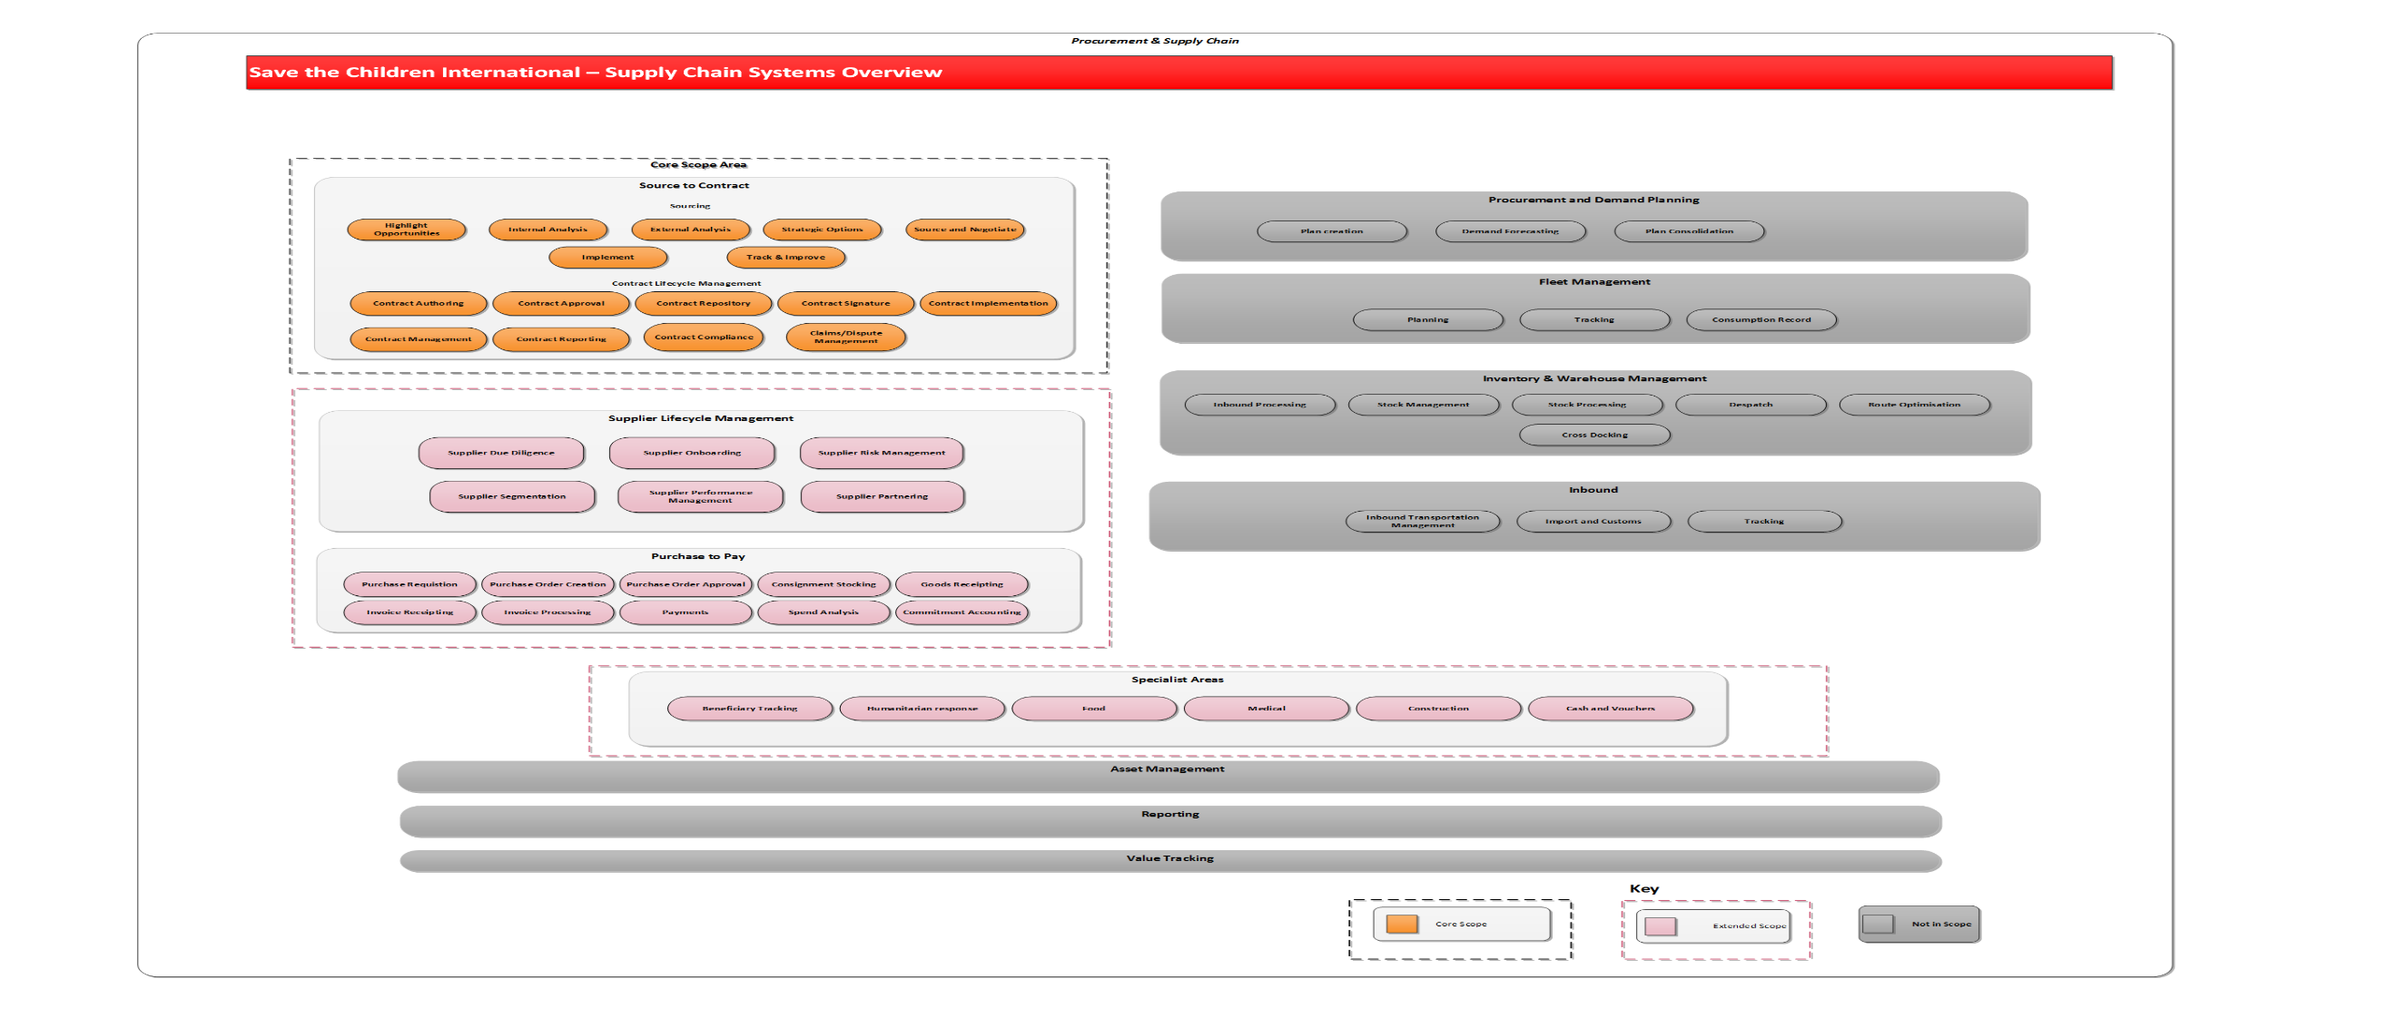

# APPENDIX C – SCI IT Design Principles

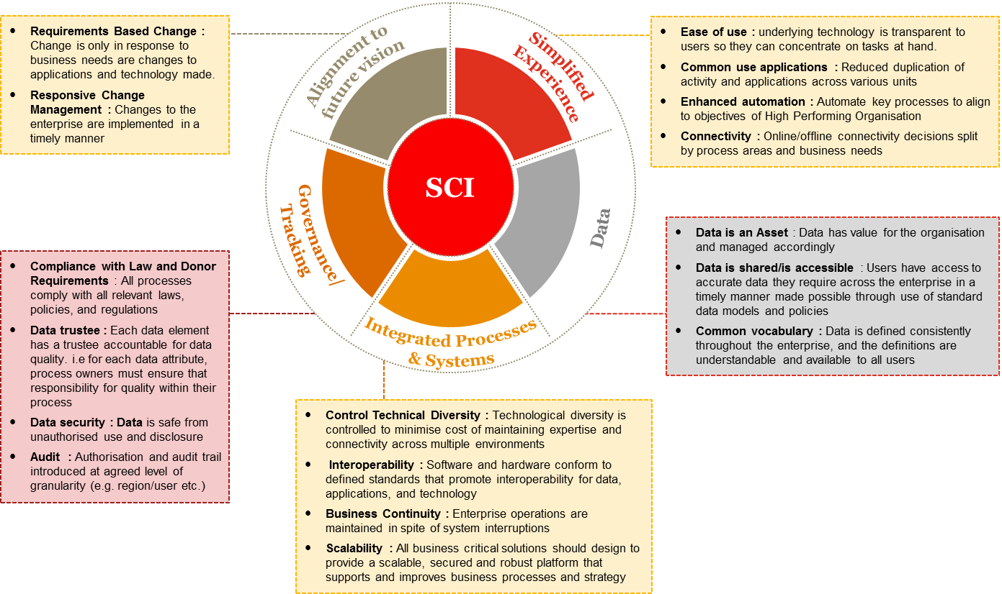

# Attachments

| **No.** | **Attachment Name** | **Attachment** |
| --- | --- | --- |
| 1 | Source to Contract Requirements |  |
| 2 | Commercial Input and Capability Overview |  |
| 3 | Supply Chain Systems Overview (for context only) |  |

# PART 2: CONDITIONS OF TENDERING

1. **Definitions**

In addition to the terms defined in the Cover Letter, in these Conditions, the following definitions apply:

(a) **Award Criteria** - the award criteria set out in the Invitation to Tender.

(b) **Bidder** - a person or organisation who bids for the tender.

(c) **Conditions** - the conditions set out in this 'Conditions of Tendering 'document.

(d) **Cover Letter** - the cover letter attached to the Tender Information Pack.

(e) **Goods and/or Services** - everything purchased by SCI under the contract.

(f) **Invitation to Tender** - the Tender Information, these Conditions, SCI’s Terms and Conditions of Purchase, SCI's Child Safeguarding Policy, SCI's Anti Bribery and Corruption Policy and the IAPG Code of Conduct.

(g) **SCI** - Save the Children International (formerly known as The International Save the Children Alliance Charity), a charitable company limited by guarantee registered in England and Wales (company number 03732267; charity number 1076822) whose registered office is at St Vincent House, 30 Orange Street, London, WC2H 7HH.

(h) **Specification** - any specification for the Goods and/or Services, including any related plans and drawings, supplied by SCI to the Supplier, or specifically produced by the Supplier for SCI, in connection with the tender.

(i) **Supplier** - the party which provides Goods and/or Services to SCI.

1. **The Contract**

The contract awarded shall be for the supply of goods and/or services, subject to SCI’s Terms and Conditions of Purchase (attached to these Conditions). SCI reserves the right to undertake a formal review of the contract after twelve (12) months.

1. **Late tenders**

Tenders received after the Closing Date will not be considered, unless there are in SCI’s sole discretion exceptional circumstances which have caused the delay.

1. **Correspondence**

All communications from Bidders to SCI relating to the tender must be in writing and addressed to the person identified in the Cover Letter. Any request for information should be received at least 5 days before the Closing Date, as defined in the Invitation to Tender. Responses to questions submitted by any Bidder will be circulated by SCI to all Bidders to ensure fairness in the process.

1. **Acceptance of tenders**

SCI may, unless the Bidder expressly stipulates to the contrary in the tender, accept whatever part of a tender that SCI so wishes. SCI is under no obligation to accept the lowest or any tender.

1. **Alternative offer**

If the Bidder wishes to propose modifications to the tender (which may provide a better way to achieve SCI’s Specification) these may, at SCI's discretion, be considered as an Alternative Offer. The Bidder must make any Alternative Offer in a separate letter to accompany the Tender. SCI is under no obligation to accept Alternative Offers.

1. **Prices**

Tendered prices must be shown as both inclusive of and exclusive of any Value Added Tax chargeable or any similar tax (if applicable).

1. **No reimbursement of tender expenses**

Expenses incurred in the preparation and dispatch of the tender will not be reimbursed.

1. **Non Disclosure and Confidentiality**

Bidders must treat the Invitation to Tender, contract and all associated documentation (including the Specification) and any other information relating to SCI’s employees, servants, officers, partners or its business or affairs (the "**Confidential Information**”) as confidential. All Bidders shall:

* recognise the confidential nature of the Confidential Information;
* respect the confidence placed in the Bidder by SCI by maintaining the secrecy of the Confidential Information;
* not employ any part of the Confidential Information without SCI's prior written consent, for any purpose except that of tendering for business from SCI;
* not disclose the Confidential Information to third parties without SCI's prior written consent;
* not employ their knowledge of the Confidential Information in any way that would be detrimental or harmful to SCI;
* use all reasonable efforts to prevent the disclosure of the Confidential Information to third parties;
* notify SCI immediately of any possible breach of the provisions of this Condition 9 and acknowledge that damages may not be an adequate remedy for such a breach.

1. **Award Procedure**

SCI’s Tender Review Committee will review the Bidders and their tenders to determine, in accordance with the Award Criteria, whether they will award the contract to any one of them.

1. **Information and Record Keeping**

SCI shall consider any reasonable request from any unsuccessful Bidder for feedback on its tender and, where it is appropriate and proportionate to do so, provide the unsuccessful Bidder with reasons why its tender was rejected. Where applicable, this information shall be provided within 30 business days from (but not including) the date on which SCI receives the request.

1. **Anti-Bribery and Corruption**

All Bidders are required to comply fully with SCI’s Anti-Bribery and Corruption Policy (attached to these Conditions).

1. **Child Protection**

All Bidders are required to comply fully with SCI’s Child Safeguarding Policy (attached to these Conditions).

1. **Exclusion Criteria**

Any Bidder is required to confirm in writing that:

* Neither it nor any related company to which it regularly subcontracts is insolvent or being wound up, is having its affairs administered by the courts, has entered into an arrangement with creditors, has suspended business activities, is the subject of  proceedings concerning those matters, or are in any analogous  situation arising from a similar procedure provided for in national  legislation or regulations;
* Neither it nor a company to which it regularly subcontracts has been convicted of fraud, corruption, involvement in a criminal organisation, any money laundering offence, any offence concerning professional conduct, breaches of applicable labour law or labour tax legislation or any other illegal activity by a judgment in any court of law whether national or international;
* Neither it nor a company to which it regularly subcontracts has failed to comply with its obligations relating to the payment of social security contributions or the payment of taxes in accordance with the legal provisions of the relevant country in which it the Bidder operates.

Any Bidder will automatically be excluded from the tender process if it is found that they are guilty of misrepresentation in supplying the required information within their tender bid or fail to supply the required information.

1. **Conflict of Interest / Non Collusion**

Any Bidder is required to confirm in writing:

* That it is not aware of any connection between it or any of its directors or senior managers and the directors and staff of SCI which may affect the outcome of the selection process. If there are such connections the Bidder is required to disclose them.
* Whether or not there are any existing contacts between SCI, and any other Save the Children entity, and it and if there are any arrangements which have been put in place over the last twenty four (24) months.
* That it has not communicated to anyone other than SCI the amount or approximate amount of the tender.
* That it has not and will not offer pay or give any sum of money commission, gift, inducement or other financial benefit directly or indirectly to any person for doing or omitting to do any act in relation to the tender process.

1. **Assignment and novation**

All Bidders are required to confirm that they will if required be willing to enter into a contract on similar terms with either SCI or any other Save the Children entity if so required.

# PART 3: TERMS AND CONDITIONS OF PURCHASE

**1 Definitions and Interpretation**

These terms and conditions ("Conditions") provide the basis of the contract between the supplier ("Supplier") and Save the Children International (the "Customer"), in relation to the purchase order ("Order") (the Order and the Conditions are together referred to as the "Contract"). All references in these terms and conditions to defined terms - Goods, Services, Prices and Delivery - refer to the relevant provisions of the Order.

**2 Quality and Defects**

2.1 The Goods and the Services shall, as appropriate:

a) correspond with their description in the Order and any applicable specification;

b) comply with all applicable statutory and regulatory requirements;

c) be of the highest quality and fit for any purposes held out by the Supplier or made known to the Supplier by the Customer;

d) be free from defects in design, material, workmanship and installation; and

e) be performed with the best care, skill and diligence in accordance with best practice in the Supplier's industry, profession or trade.

2.2 The Customer (including its representatives or agents) reserves the right at any time to audit the Supplier’s records, inspect work being undertaken in relation to the supply of the Goods and Services and, in the case of Goods, to test them.

**3 Ethical Standards**

3.1 The Supplier shall observe the highest ethical standards during the performance of its obligations under this Contract including international labour standards promoted by the International Labour Organisation specifically in the areas of child labour and forced labour.

3.2 The Supplier, its suppliers and sub-contractors shall comply with all environmental statutory and regulatory requirements and shall not in any way be involved in (a) the manufacture or sale of arms or have any business relations with armed groups or governments for any war related purpose; or (b) terrorism, including checking its staff, suppliers and sub-contractors against the following sanctions lists: UK Treasury List, EC List, OFAC List and US Treasury List.

3.3 The Supplier shall comply with the following Customer Policies, which are available upon request: Child Safeguarding; and Anti-Bribery and Corruption.

**4 Delivery / Performance**

4.1 The Goods shall be delivered to, and the Services shall be performed at the address and on the date or within the period stated in the Order, and in either case during the Customer's usual business hours, except where otherwise agreed in the Order. Time shall be of the essence in respect of this Condition 4.1.

4.2 Where the date of delivery of the Goods or of performance of Services is to be specified after issue of the Order, the Supplier shall give the Customer reasonable written notice of the specified date.

4.3 Delivery of the goods shall take place and title in the Goods will pass on the completion of the physical transfer of the goods from the Supplier or its agents to the Customer or its agents at the address specified in the Order.

4.4 Risk of damage to or loss of the Goods shall pass to the Customer in accordance with the relevant provisions of Incoterms rules as in force at the date the Contract is made or, where Incoterms do not apply, risk in the Goods shall pass to the Customer on completion of delivery.

4.5 The Customer shall not be deemed to have accepted any Goods or Services until the Customer has had reasonable time to inspect them following delivery and/or performance by the Supplier.

4.6 The Customer shall be entitled to reject any Goods delivered or Services supplied which are not in accordance with the Contract. If any Goods or Services are so rejected, at the Customer's option, the Supplier shall forthwith re-supply substitute Goods or Services which conform with the Contract. Alternatively, the Customer may cancel the Contract and return any rejected Goods to the Supplier at the Supplier's risk and expense.

**5 Indemnity**

The Supplier shall indemnify the Customer in full against all liability, loss, damages, costs and expenses (including legal expenses) awarded against or incurred or paid by the Customer as a result of or in connection with any act or omission of the Supplier or its employees, agents or sub-contractors in performing its obligations under this Contract, and any claims made against the Customer by third parties (including claims for death, personal injury or damage to property) arising out of, or in connection with, the supply of the Goods or Services.

**6 Price and Payment**

Payment in arrears will be made as set out in the Order and the Customer shall be entitled to off-set against the price set out in the Order all sums owed to the Customer by the Supplier.

**7 Termination**

7.1 The Customer may terminate the Contract in whole or in part at any time and for any reason whatsoever by giving the Supplier at least one month’s written notice.

7.2 The Customer may terminate the Contract with immediate effect by giving written notice to the Supplier and claim any losses (including all associated costs, liabilities and expenses including legal costs) back from the Supplier at any time if the Supplier:

a) becomes insolvent, goes into liquidation, makes any voluntary arrangement with its creditors, or becomes subject to an administration order; or

b) is in material breach of its obligations under the Contract or is in breach of its obligations and fails to remedy such breach within 14 days of written request from the Customer.

7.3 In the event of termination, all existing purchase orders must be completed.

**8 Supplier's Warranties**

8.1 The Supplier warrants to the Customer that:

a) it has all necessary internal authorisations and all authorisations from all relevant third parties to enable it to supply the Goods and the Services without infringing any applicable law, regulation, code or practice or any third party’s rights;

b) it will not and will procure that none of its employees will accept any commission, gift, inducement or other financial benefit from any supplier or potential supplier of the Customer; and

c) the Services will be performed by appropriately qualified and trained personnel, with the best care, skill and diligence and to such high standard of quality as it is reasonable for the Customer to expect in all the circumstances.

**9 Force majeure**

9.1 Neither party shall be liable for any failure or delay in performing its obligations under the Contract to the extent that such failure or delay is caused by an event that is beyond that party's reasonable control (a "Force Majeure Event") provided that the Supplier shall use best endeavours to cure such Force Majeure Event and resume performance under the Contract.

9.2 If any events or circumstances prevent the Supplier from carrying out its obligations under the Contract for a continuous period of more than 14 days, the Customer may terminate the Contract immediately by giving written notice to the Supplier.

**10 General**

10.1 The Supplier shall not use the Customer's name, branding or logo other than in accordance with the Customer's written instructions or authorisation.

10.2 The Supplier may not assign, transfer, charge, subcontract, novate or deal in any other manner with any or all of its rights or obligations under the Contract without the Customer's prior written consent.

10.3 Any notice under or in connection with the Contract shall be given in writing to the address specified in the Order or to such other address as shall be notified from time to time. For the purposes of this Condition, "writing" shall include e-mails and faxes.

10.4 If any court or competent authority finds that any provision of the Contract (or part of any provision) is invalid, illegal or unenforceable, that provision or part-provision shall, to the extent required, be deemed to be deleted, and the validity and enforceability of the other provisions of the Contract shall not be affected.

10.5 Any variation to the Contract, including the introduction of any additional terms and conditions, shall only be binding when agreed in writing and signed by both parties.

10.6 The Contract shall be governed by and construed in accordance with English law. The parties irrevocably submit to the exclusive jurisdiction of the courts of England and Wales to settle any dispute or claim arising out of or in connection with the Contract or its subject matter or formation.

10.7 A person who is not a party to the Contract shall not have any rights under or in connection with it.

# PART 4: SAVE THE CHILDREN’S CHILD SAFEGUARDING POLICY

**Our values and principles**

Child abuse is when anyone under 18 years of age is being harmed or isn't being looked after properly. The abuse can be physical, sexual, emotional or neglect. The abuse and exploitation of children happens in all countries and societies across the world. Child abuse is never acceptable.

It is expected that all who work with Save the Children are committed to safeguard children whom they are in contact with.

**What we do**

Save the Children is committed to safeguard children through the following means:

**Awareness:** Ensuring that all staff and those who work with Save the Children are aware of the problem of child abuse and the risks to children.

**Prevention:** Ensuring, through awareness and good practice, that staff and those who work with Save the Children minimise the risks to children.

**Reporting:** Ensuring that you are clear on what steps to take where concerns arise regarding the safety of children.

**Responding:** Ensuring that action is taken to support and protect children where concerns arise regarding possible abuse.

To help you clarify our safeguarding approach, we list here examples of the behaviour by a representative of Save the Children which are prohibited. These include but are not limited to:

1. Hitting or otherwise physically assaulting or physically abusing children.
2. Engaging in sexual activity or having a sexual relationship with anyone under the age of 18 years regardless of the age of majority/consent or custom locally. Mistaken belief in the age of a child is not a defence.
3. Developing relationships with children which could in any way be deemed exploitative or abusive.
4. Acting in ways that may be abusive in any way or may place a child at risk of abuse.
5. Using language, making suggestions or offering advice which is inappropriate, offensive or abusive.
6. Behaving physically in a manner which is inappropriate or sexually provocative.
7. Sleeping in the same bed or same room as a child, or having a child/children with whom one is working to stay overnight at a home unsupervised.
8. Doing things for children of a personal nature that they can do themselves.

1. Condoning, or participating in, behaviour of children which is illegal, unsafe or abusive.
2. Acting in ways intended to shame, humiliate, belittle or degrade children, or otherwise perpetrate any form of emotional abuse.
3. Discriminating against, showing unfair differential treatment or favour to particular children to the exclusion of others.
4. Spending excessive time alone with children away from others.
5. Placing oneself in a position where one is made vulnerable to allegations of misconduct.

In order that the above standards of reporting and responding are met, **this is what is expected of you**:

If you are worried that a child or young person is being abused or neglected, (such as in points 1, 2, 3, 4, 6, 8, 9 and 10 above for example) or you are concerned about the inappropriate behaviour of an employee, or someone working with Save the Children, towards a child or young person, then you are obliged to:

* act quickly and get help
* support and respect the child
* where possible, ensure that the child is safe
* contact your Save the Children manager with your concerns immediately (or their senior manager if necessary)
* keep any information confidential to you and the manager.

If you want to know more about the Child Safeguarding Policy then please contact your Save the Children manager.

# PART 5: SAVE THE CHILDREN’S ANTI-BRIBERY AND CORRUPTION POLICY

**Our values and principles**

Save the Children does not allow any partner, supplier, sub-contractor, agent or any individual engaged by Save the Children to behave in a corrupt manner while carrying out Save the Children’s work.

**What we do**

Save the Children is committed to preventing acts of bribery and corruption through the following means:

**Awareness:** Ensuring that all staff and those who work with Save the Children are aware of the problem of bribery and corruption.

**Prevention:** Ensuring, through awareness and good practice, that staff and those who work with Save the Children minimise the risks of bribery and corruption.

**Reporting:** Ensuring that all staff and those who work with Save the Children are clear on what steps to take where concerns arise regarding allegations of bribery and corruption.

**Responding:** Ensuring that action is taken to support and protect assets and identifying cases of bribery and corruption.

To help you identify cases of bribery and corruption, behaviour which amounts to corruption includes but is not limited to:

* 1. Paying or Offering a Bribe – where a person improperly offers, gives or promises any form of material benefit or other advantage, whether in cash or in kind, to another in order to influence their conduct in any way.
  2. Receiving or Requesting a Bribe – where a person improperly requests, agrees to receive or accepts any form of material benefit or other advantage, whether in cash or in kind, which influences or is designed to influence the individual’s conduct in any way.
  3. Receiving or Paying a so-called ‘Grease’ or ‘Facilitation’ payment – where a person improperly receives something of value from another party for performing a service or other action that they were required by their employment to do anyway.
  4. Nepotism or Patronage – where a person improperly uses their employment to favour or materially benefit friends, relatives or other associates in some way. For example, through the awarding of contracts or other material advantages.
  5. Embezzlement - where a person improperly uses funds, property, resources or other assets that belong to an organisation or individual.
  6. Receiving a so-called ‘Kickback’ Payment – where a person improperly receives a share of funds, a commission, material benefit or other advantage from a supplier as a result of their involvement in a corrupt bid or tender process.
  7. Collusion – where a person improperly colludes with others to circumvent, undermine or otherwise ignore rules, policies or guidance.
  8. Abuse of a Position of Trust – where a person improperly uses their position within their organisation to materially benefit themselves or any other party.

In order that the above standards of reporting and responding are met, **this is what is expected of you**:

You have a duty to protect the assets of Save the Children from any form of corruption. Furthermore, you must immediately report any suspicion of bribery or corruption to the Save the Children senior management team or Country Director and not to anyone else. Failure to report will be treated as serious and may result in termination of any agreement with Save the Children.

You are obliged to:-

* act quickly and get help
* encourage your own staff to report on bribery and corruption
* contact the Save the Children senior management team or Country Director with your concerns immediately (or their senior manager if necessary)
* keep any information confidential to you and the manager.

Attempted corruption is as serious as the actual acts and will be treated in the same way under this policy.

If you want to know more about the Anti-Bribery and Corruption Policy then please contact your Save the Children representative.



# PART 6: CODE OF CONDUCT FOR IAPG AGENCIES AND SUPPLIERS

Suppliers and manufacturers to Non Governmental Organisations (NGO’s) should be aware of the Code of Conduct initiatives that the Inter-Agency Procurement Group (IAPG) support. This information is to advise you, our suppliers, of the Corporate Social Responsibility (CSR) element in our supplier relationships.

* Goods and services purchased are produced and developed under conditions that do not involve the abuse or exploitation of any persons.
* Goods produced and delivered by organisations subscribe to no exploitation of children
* Goods produced and manufactured have the least impact on the environment

**Code of Conduct for Suppliers:**

Goods and services are produced and delivered under conditions where:

* Employment is freely chosen
* The rights of staff to freedom of association and collective bargaining are respected.
* Living wages are paid
* There is no exploitation of children
* Working conditions are safe and hygienic
* Working hours are not excessive
* No discrimination is practised
* Regular employment is provided
* No harsh or inhumane treatment of staff is allowed.

**Environmental Standards:**

Suppliers should as a minimum comply with all statutory and other legal requirements relating to environmental impacts of their business. Areas to be considered are:

* Waste Management
* Packaging and Paper
* Conservation
* Energy Use
* Sustainability

**Business Behaviour:**

IAPG members will seek alternative sources where the conduct of suppliers demonstrably violates anyone’s basic human rights, and there is no willingness to address the situation within a reasonable timeframe.

IAPG members will seek alternative sources where companies in the supply chain are involved in the manufacture of arms or the sale of arms to governments which systematically violate the human rights of their citizens.

**Qualifications to the statement**

Where speed of deployment is essential in saving lives, IAPG members will purchase necessary goods and services from the most appropriate available source.

**Disclaimer**

This Code of Conduct does not supersede IAPG Members’ individual Codes of Conduct. Suppliers are recommended to check the Agencies’ own websites.